



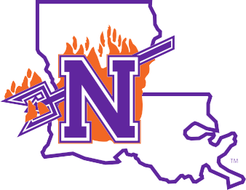
How to setup Multi-Factor Authentication (MFA) using
Microsoft

First Time User

- Visit https://my.nsula.edu
- Input your username and password
- When prompted for more information required, click Next
- Download the Microsoft Authenticator app, click

Next
- Launch the Microsoft Authenticator app and select "Verified IDs"
- Scan the QR code, click Next
- Input your 2-digit code into the appropriate field, click Next
- You should receive notification that the Authenticator app was successfully registered
- Confirm the Authenticator app is your default sign-in method then select Done
- Welcome to the myNSU Dashboard!

If you require further assistance, please feel free to contact the NSU Student Help Desk at (318) 357-6696 or via email at sos@nsula.edu.



Please Note
Top Public Schools | Regional Universities | South
The Microsoft Authenticator app binds the account connection to the specific device used during the setup process. If a user's mobile device is replaced for any reason, they will need to completely setup the Microsoft Authenticator app again on the new device.

